1. 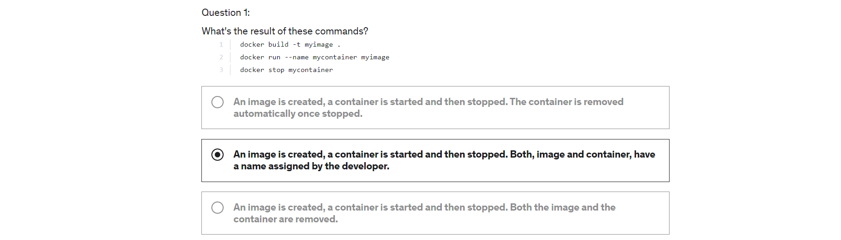
2. Graphical user interface, text, application

   Description automatically generated
3. A picture containing text

   Description automatically generated
4. Graphical user interface, text, application, email

   Description automatically generated
5. Graphical user interface, text, application

   Description automatically generated